Machine Learning (EECE 6822)



Project Draft2

Mohammad Saber
(MUID: 005852837)

Due date of submission: 04/16/2015

Short-term Load Forecasting using SECRET method

Mohammad Saber
Dept. of Electrical and Computer Engineering
Marquette University
Milwaukee, WI, USA
mohammad.saber@marquette.edu
Richard J. Povinelli
Dept. of Electrical and Computer Engineering
Marquette University
Milwaukee, WI, USA
richard.povinelli@marquette.edu

Abstract— A regression tree is a very simple and effective way to predict the future based on historical data. Over the years, there are many works to increase accuracy, better scalability and less time complexity of the original regression tree algorithm [1]. In this paper, an improved version of original regression tree called SECRET method (Scalable Linear Regression Tree [10]) has been used to forecast short term electric load which is considered very important in electric industry for low cost uninterrupted power supply for the customers.
Index Terms—Load forecasting, Regression tree, SECRET.

Introduction
Load forecasting is very important for power generation and distribution companies to make valuable decisions ahead of time that can ultimately maximize their business profit. It also helps the local power distribution companies to increase their quality of service for customers by providing uninterrupted flow with required level of voltage [2]. Based on the forecast time horizon there are three categories of load forecasting. The forecasting range of one hour to one week is considered as short-term load forecasting whereas one week to one year duration of forecast and more than one year of forecast are called as mid-term and long-term load forecast respectively [2]. If the forecasting duration is less than one hour then it is called very short-term load forecasting [3]. Different kind of historical data is helpful for different categories of forecast. For short-term load forecasting, weather conditions (temperature, wind speed, cloud cover, precipitation) and calendar (day of the week, weekend, weekdays) are considered as most useful factors. Forecasting result of electric load heavily depends on whether condition and weather is a non-linear chaotic system. Thus it’s very difficult to accurately predict weather for long duration, which implies that mid-term and long-term load forecast based on long-term weather forecasting data is more vulnerable than short-term load forecasting. For the mid-term and long-term load forecasting, historical data of demand and climate (humidity, temperature, humidity temperature index), economic report (economic activities of country, economic variables which effects energy demand), number of users, their purchasing capacity and their lifestyle [3]. Considering difficulty and uncertainty level of data for long-term load forecast, short-term load forecasting is more useful and popular. Thus most of the literature in load forecasting research area focus on short-term load forecasting.
Many techniques have been used for load forecasting. Linear regression model [4, 5] and artificial neural networks [6, 7] are the most popular techniques. Other techniques like support vector machine [2, 8], Gray forecasting model [8], Fuzzy inference model [11], Decision tree [10], ANFIS [2] (mixture of artificial neural network and fuzzy logic) are also used for load forecasting. Linear regression is the easiest method to get a decent forecast accuracy with less calculation. As mentioned earlier weather data is non-linear, thus the accuracy of linear regression forecasting model based on non-linear data is lower than other artificial neural network on testing dataset. But in practice we can observe that artificial neural network can’t predict well in case of sharp changes of weather. Thus linear regression is still most popular method for load forecasting. Regression tree works better for non-linear data. The improved version of regression tree algorithm uses linear regression on leave nodes of regression tree rather than using simple average which gives better result than linear regression model on non-linear dataset. But the timing complexity of regression tree with linear regression leaves was polynomial which makes it difficult to use for big datasets. SECRET method [10] improves the timing complexity of regression tree with regression leaves. Now regression trees with regression leave can be built in linear time using SECRET method which makes this process attractive to apply for big datasets. In this paper, original electricity demand data of a power distribution company (Central Hudson, USA) has been used to forecast hourly electricity demand for one week in advance.

SECRET ALGORITHM
The main idea of the SECRET algorithm [10] is to locally transfer the regression problem into a classification problem using EM algorithm for Gaussian mixtures and then classify the data points based on the probability of belonging to these two distributions. Classification tree techniques are then used to select split attribute and split point. Efficient implementation of EM algorithm, split point and split attribute selection method were explained in next section. This proposed algorithm works for both discrete and continuous attributes. Fig. 1 contains the flow chart of SECRET algorithm.

- Flow chart of SECRET algorithm
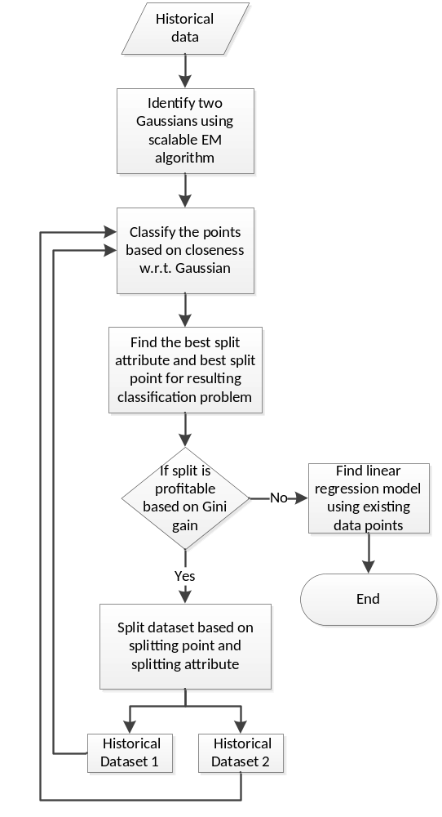

EXPERIMENTAL RESULTS
Table 1 shows that SECRET algorithm gives less error on Central Hudson electricity dataset.
- Table Type Styles
 | Comparision between SECRET and linear regresstion
 |  | SECRET | LR
 | Mean absolute error | 59.87 | 91.23
 | Root mean squared error | 75.21 | 113.64
a. Sample of a table footnote. (table footnote)

- Error is high for both method, I will use time series in WEKA to get more reasonable error.
- I will include some graphs and write more about dataset.
- In will complete conclusion next time.

cONCLUSION
After collecting some results, this section will contain discussion on result and some future scope of works.

References
- J. R. Quinlan, “Induction of Decision Trees”, Machine Learning 1, 1986, pp. 81-106.
- A. Escobar M and L.P. Perez., “Application of Support Vector Machines and ANFIS to the Short-term Load Forecasting”, Transmission and Distribution Conference and Exposition: Latin America, IEEE, 2008, pp. 1-5.
- Pang Qingle and Zhang Min, “Very Short-Term Load Forecasting Based on Neural Network and Rough Set”, International Conference on Intelligent Computation Technology and Automation, IEEE, 2010, pp. 1132-1135.
- Tao Hong, and Jason Wilson, “Long Term Probabilistic Load Forecasting and Normalization With Hourly Information”, IEEE transaction of smart grid, vol. 5, no. 1, 2014, pp. 456-462.
- Richard Cebula and Nate Herder, “An Empirical Analysis of Determinants of Commercial and industrial Electricity Consumption”, MPRA, paper no. 56763, 2014.
- Du Xin-hui, Tian Feng, and Tan Shao-qiong, “Study of Power System Short-term Load Forecast Based on Artificial Neural Network and Genetic Algorithm”, 2010 International Conference on Computational Aspects of Social Networks, IEEE, 2010, pp. 725 – 728.
- Xiaorong Sun, peter B. Luh, Laurent D. Michel, Stephen Corbo, Kwok W. Cheung, and Wei Guan, “An Efficient Approach for Short-Term Substation Load Forecasting”, Power and Energy Society General Meeting, IEEE, 2013, pp. 1-5.
- Xin Jin, Jie Wu, Yao Dong, Dezhong Chi, “Application of A Hybrid Model to Short-Term Load Forecasting”, International Conference of Information Science and Management Engineering, IEEE, 2010, pp. 492 – 497.
- Qia Ding, “Long-Term Load Forecast Using Decision Tree Method”, Power Systems Conference and Expostion, IEEE, 2006, pp. 1541-1543.
- Alin Dobra, and Johannes Gehrke, “SECRET: A Scalable Linear Regression Tree Algorithm”, Proceedings of the eighth ACM SIGKDD international conference on Knowledge discovery and data mining, ACM, 2002, pp. 481-487.
- Saleh Ahmadi, Hassan Bevrani, and Hannah Jannaty, “A fuzzy inference model for short-term load forecasting”, Second Iranian Conference on Renewable Energy and Distributed Generation, IEEE, 2012, pp. 39-44.

